Appnote AN0020 rev 0 Matrix and Vector Menus 2D & 3D 2026-07-15

R47/C47 Matrix and Vector Menus including Vectors 2D & 3D
R47/C47 Matrix and Vector Menus including Vectors 2D & 3D 1
R47/C47 Matrix and Vector Introduction 2
Matrix and Vector functions 3
Matrices and Vectors — Worked Examples 4
Row and Column Operations 4
Norms 4
Decompositions 5
Vector Products 5
Matrix Operations 5
Unit Vector and Linear System 5
More examples 5
Vectors, 2D & 3D functions 7
Vector operations: 7
Coordinate systems and notation 8
Coordinate conversions (using the default [i j k] Math-style vector options): 8
Not implemented in 2D and 3D: 9
Scalar operations from both 2D and 3D pages: 9
2D vector operations: 10
3D vector operations: 11
2D and 3D Examples with formulas 12
Cartesian to Cylindrical 12
Cylindrical to Spherical 12
Spherical to Cartesian 12
Rectangular to Polar 12
Polar to Rectangular 12
Practical 2D vector problem, from the HP25 Operating Manual, p70 13
Practical 2D vector problem, from the HP-32E Operating Manual, p28 14

R47/C47 Matrix and Vector Introduction
A scalar is a single number. An ordered list of single numbers is a vector ΁. A rectangular arrangement of i rows and j columns of single numbers is a matrix M. A vector is the special case where one of those dimensions is 1. The single number statement here includes complex numbers.
The R47/C47 supports matrices of arbitrary dimension, with 1×2, 2×1, 1×3 or 3×1 matrixes automatically recognised and handled as 2D vectors (΁₂) or 3D vectors (΁₃) respectively. Any single-row or single-column matrix is treated as a generic vector V. Both real and complex matrices M and vectors V are supported throughout, but 2D and 3D vectors are defined as real only.
Matrix addition and subtraction require identical dimensions. Multiplying an i×n matrix by an n×j matrix yields an i×j result. Scalar operations like LOG, SIN, |x| and many more apply element-wise.
For square M, the determinant |M|, transpose Mᵀ, and inverse M⁻¹ are defined; M⁻¹ exists only when |M| ≠ 0. Division of M by a square matrix B is multiplication by B⁻¹. Two factorisations are available: M.LU returns the upper triangular factor U with partial pivoting applied, and M.QR returns the upper triangular factor R.
Solving M͸ = ā yields ͸ = M⁻¹ ā, unique when M is square and non-singular.
For a square M, eigenvalue λ and eigenvector ΁ satisfy M΁ = λ΁. EIGVAL returns eigenvalues as roots of det(M − λI) = 0, which may be real or complex regardless of whether M is real. EIGVEC returns the eigenvectors; collecting these as columns of V gives V⁻¹MV = Λ, diagonal with eigenvalues on the main diagonal, when M is diagonalisable.
Several norms are available for any matrix or vector in x. The general p-norm is ‖x‖ₚ = (Σ|xᵢ|ᵖ)^(1/p), supported for integer p from 1 to 9, and ∞, also including 0 for convenience although NNZ is not a norm. The practically important related cases are ‖x‖₁ (maximum column sum of absolute values), ‖x‖₂ the Frobenius norm √(Σxᵢⱼ²) which reduces to the Euclidean vector magnitude, and ‖x‖₟ the row norm, being the maximum row sum of absolute element values.
For 2D and 3D vectors ΁, the R47/C47 provides a function set covering coordinate conversions, norms, inter-vector distance and angle, and cross product. Dot product is available for any conforming matrices. The axis labels follow the ijk convention (optionally xyz). All vectors are stored in rectangular form; polar, cylindrical and spherical representations are display modes only.
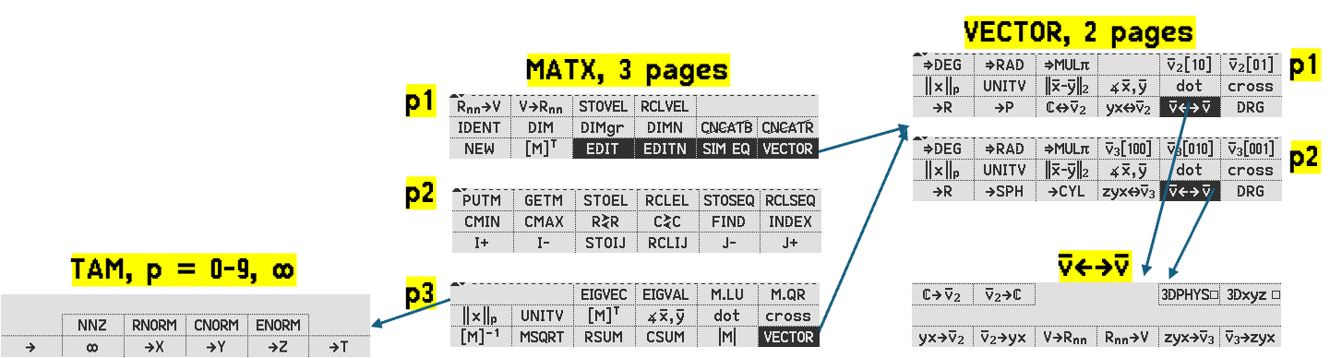
Left:
The matrix and vector menu structure for R47/C47

Matrix and Vector functions
The matrix functions available are:
- RSUM
Returns a row vector containing the sum of each row of x.
- CSUM
Returns a column vector containing the sum of each column of x.
- NNZ ‖x‖₀
Sparsity count (number of non-zero elements). Count of non-zero elements in vector and complete matrix. Scalar.
- RNORM ‖x‖∞ $= \underset{1≤i≤m}{max⁡}\sum_{j=1}^{n}{∣}a_{ij}∣$
Maximum norm. For a matrix, the maximum row sum of absolute element values; for a row vector, the sum of absolute values; for a column vector, the largest absolute element.
- CNORM ‖x‖₁ $= \underset{1≤j≤n}{max⁡}\sum_{i=1}^{m}{∣}a_{ij}∣$
L¹ norm, a.k.a. Manhattan norm. For a matrix, the maximum column sum of absolute element values; for a column vector, the sum of absolute values; for a row vector, the largest absolute element.
- ENORM ‖x‖₂ ${\left(\sum_{i=1}^{n}{∣}x_{i}∣^{2}\right)}^{1/2}$
For a vector, Euclidean magnitude. For a matrix, Frobenius norm. Σ|xᵢⱼ|².
- ‖x‖ₚ ${\left(\sum_{j=1}^{n}{ }\sum_{i=1}^{m}{∣}x_{ij}∣^{p}\right)}^{1/p}$p = 3 to 9 (for 2, see above)
General p-norm for integer p >= 2.
- M.LU
Decomposes M into lower and upper triangular factors; underlies inversion and linear solving.
- M.QR
Decomposes M into an orthogonal matrix times an upper triangular matrix; underlies eigenvalue computation.
- DOT
Dot product of two conforming matrices; returns the scalar Σaᵢⱼbᵢⱼ.
- CROSS
Cross product of two 2D or 3D vectors; returns a vector orthogonal to both operands.
- [M]⁻¹
Matrix inverse; exists only when |M| ≠ 0.
- |M|
Determinant of square matrix M.
- UNITV
Returns the unit vector/matrix in x; equivalent to x/||x||₂, x being either M or ΁. The resulting unit vector will have ||x||₂ = 1.
- SIM EQ
Solves $[A]·\vec{X}=\vec{B}$ for the unknown $\vec{X}$ given coefficient matrix [A] and constant vector $\vec{B}$.

Matrices and Vectors — Worked Examples

A = | [ 1 -2 3  4 0 -1  2 3 5 ]
B = | [ 1 2 3 ]ᵀ
X = | [ 1 2 3 ]
Y = | [ 3 1 2 ]

Row and Column Operations
RSUM of A | [ 2 3 10 ]ᵀ
RSUM of B | [ 1 2 3 ]ᵀ
RSUM of X | [ 6 ]
CSUM of A | [ 7 1 7 ]
CSUM of B | [ 6 ]
CSUM of X | [ 1 2 3 ]

Norms
NNZ ‖x‖₀ of A | = 8 (one zero at row 2, col 2)
NNZ ‖x‖₀ of B and X | = 3
RNORM ‖x‖∞ of A | row 1: 1+2+3 = 6  row 2: 4+0+1 = 5  row 3: 2+3+5 = 10 → RNORM = 10
RNORM ‖x‖∞ of B (column vector) | max(1, 2, 3) = 3 (each row one element)
RNORM ‖x‖∞ of X (row vector) | 1+2+3 = 6 (one row, all elements)
CNORM ‖x‖₁ of A | col 1: 1+4+2 = 7  col 2: 2+0+3 = 5  col 3: 3+1+5 = 9 → CNORM = 9
CNORM ‖x‖₁ of B (column vector) | 1+2+3 = 6 (one col, all elements)
CNORM ‖x‖₁ of X (row vector) | max(1, 2, 3) = 3 (each column one element)
ENORM ‖x‖₂ of A | √(1+4+9+16+0+1+4+9+25) = √69 ≈ 8.307
ENORM ‖x‖₂ of B and X | √(1+4+9) = √14 ≈ 3.742
‖x‖₃ of A | (1+8+27+64+0+1+8+27+125)^(1/3) = 261^(1/3) ≈ 6.391

Decompositions
M.LU of A (M.LU of A (upper triangular U, partial pivoting applied)) | [ 4 0 -1  0 3 5.5  0 0 6.917 ]
M.QR of A (M.QR of A (upper triangular R, partial pivoting applied) | [ -4.58 -0.87 -1.97  - -3.50 -2.08  0 0 5.18 ]

Vector Products
DOT of X and Y | 3×1 + 1×2 + 2×3 = 3+2+6 = 11
CROSS of X and Y | (1×3−2×2)i + (2×1−3×3)j + (3×2−1×1)k  = [ -1 -7 5 ]

Matrix Operations
|A| determinant of A | 1×(0×5−(−1)×3) − (−2)×(4×5−(−1)×2) + 3×(4×3−0×2)  = 3 + 44 + 36 = 83
[A]⁻¹ inverse of A | = (1/83) × [ 3 19 2  -22 -1 13  12 -7 8 ]  ≈ [ 0.036 0.229 0.024  -0.265 -0.012 0.157  0.145 -0.084 0.096 ]

Unit Vector and Linear System
UNITV of B = B/‖B‖₂ | = [ 1/√14 2/√14 3/√14 ]ᵀ  ≈ [ 0.267 0.535 0.802 ]ᵀ
SIM EQ solves A·X = B  A in Mat_A; B in Mat_B; result => Mat_X  or use RCL A [M]^-1 RCL B × | = (1/83)×[ 47 15 22 ]ᵀ  ≈ [ 0.566 0.181 0.265 ]ᵀ

More examples
Change variables: | B = [1 2 3]^{T}  X = [4 5 6]  A = [1 2 3 C = [1 2 1  4 5 6 0 1 3  7 8 9] 2 0 1]
RSUM of A in x | [6, 15, 24]
CSUM of A in x | [12, 15, 18]
NNZ of A in x = ‖x‖₀ | 9
RNORM of A in x = ‖x‖∞ = max₁≤i≤m ∑ⱼ₌₁ⁿ |aᵢⱼ| | max([6, 15, 24]) = 24
CNORM of A in x = ‖x‖₁ = max₁≤j≤n ∑ᵢ₌₁ᵐ |aᵢⱼ| | max([12, 15, 18]) = 18
ENORM of A in x = ‖x‖₂ = (∑ᵢ₌₁ⁿ |xᵢ|²)^(1/2) | = sqrt(1²+2²+3²+4²+5²+6²+7²+8²+9²)  = sqrt(285) ≈ 16.88
‖x‖ₚ of A in x =(∑ⱼ₌₁ⁿ ∑ᵢ₌₁ᵐ |xᵢⱼ|ᵖ)^(1/p) p=3 | =(1+8+27+64+125+216+343+512+729)^(1/3)  =(2025)^(1/3) ≈ 12.66
DOT of A in x and B in y | [1 2 3 [1*1 + 2*2 + 3*3  4 5 6 ● [1 2 3]T = 4*1 + 5*2 + 6*3  7 8 9] 7*1 + 8*2 + 9*3]  = [14 32 50]^{T}
CROSS of B in x and B in y | = [2*3-3*2, 3*1-1*3, 1*2-2*1]^{T}  = [0 0 0]^{T}
[M]⁻¹ of C in x | = [ 1/11 -2/11 5/11  6/11 -1/11 -3/11  -2/11 4/11 1/11 ] use IRFRAC mode)
|M| of C in x | = 11
UNITV of B in x = B/‖B‖₂ | = [1/√14, 2/√14, 3/√14]  ≈ [0.267, 0.535, 0.802]
SIM EQ: AX = B  C in Mat_A; B in Mat_B; result Mat_X | X ≈ [1.09 -0.455 0.818]

Vectors, 2D & 3D functions
Vectors are fundamental objects in physics and engineering, yet scientific calculators have historically given them limited native support. This application note describes the R47/C47 vector implementation, which treats 2D and 3D vectors as first-class register objects with full polar, cylindrical and spherical display support.
The core design philosophy is clean: vectors are always stored in rectangular form. Polar, cylindrical and spherical representations are a display and entry convenience, not a separate storage format. This means all element-wise arithmetic operates on the underlying rectangular values and always returns a rectangular result, regardless of how the vector was entered or is currently displayed.
The implementation covers the complete set of vector operations one would expect: Euclidean norm, unit vector, dot and cross products, inter-vector distance and angle, and the full suite of coordinate conversions between rectangular, polar, cylindrical and spherical forms. Both 2D and 3D vectors are supported, with 2D polar and 3D spherical/cylindrical mode tagging carried through operations where it makes sense, for example:
- [5 0.927^{r} 5]^{C} 3D vector, tagged cylindrical, tagged as an angle of 0.927 radians
- [3 4 5] 3D vector, not tagged, the native underlying format of ijk or xyz visible
The axis labelling follows the conventional ijk notation used in engineering and physics, with an option to switch to xyz. Angle modes follow the calculator's active angle mode and can be converted freely using the usual double-arrow conversion keys.

Vector operations:
All vectors are stored as rectangular 1×2 or 1×3 matrices. Polar, cylindrical and spherical forms are display representations only, controlled by register tagging. Any matrix function will clear the polar tag and return the vector to the default rectangular display state.
Example: All element wise operations (+, -, ×, /, y^x, √x, etc.) are executed on the underlying rectangular coordinate values, regardless of the polar display status of the vector.
- [3 4 5] 2 [×] will result in [6 8 10]
- [3 4 5] [→SPH] 2 [×] will result in [6 8 10]
- [5 0.927^{r} 5]^{C} [3 4 5] [+] will result in [6 8 10]

- EDIT: Polar mode vector editing is not supported
- SHOW: No special vector or matrix SHOW display exists
- STO/RCL VEL1, 2, n: Vector element recalls underlying rectangular coordinates

Coordinate systems and notation
All vectors stored as rectangular [i j] (2D) or [i j k] (3D).
An alternative display using x & y, i.e. [x y] and [x y z] is available using the option flag [3DXYZ] in both the ΁←→΁ vector conversion menu and the system flags in CFLG menu.
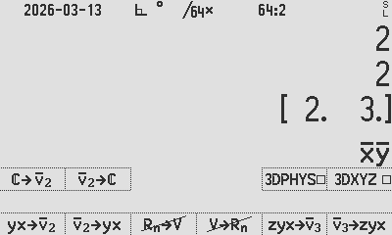
Display modes tag the stored rectangular values; all element-wise operations act on the underlying rectangular components. Component ordering by display mode:
 | 3DXYZ clear |  |  | 3DXYZ set
Display mode | Z | Y | X | Z | Y | X
Cartesian 2D |  | i | j |  | x | y
Cartesian 3D | i | j | k | x | y | z
Polar 2D |  | r | θᵢⱼ |  | r | θ_{xy}
Cylindrical 3D | r | θᵢⱼ | k | r | θ_{xy} | z

Math Vectors | 3DPHYS clear
Spherical 3D | ρ | θᵢⱼ | φₖ | ρ | θ_{xy} | φ_{z}
Physics Vectors | 3DPHYS set
Spherical 3D | ρ | φₖ | θᵢⱼ | ρ | φ_{z} | θ_{xy}

Coordinate conversions (using the default [i j k] Math-style vector options):
Rectangular → Polar (2D): [i, j] → [r, θᵢⱼ]
r = √(i² + j²), θᵢⱼ = atan2(j, i)
Polar → Rectangular (2D): [r, θᵢⱼ] → [i, j]
i = r·cos(θᵢⱼ), j = r·sin(θᵢⱼ)
Cartesian → Cylindrical (3D): [i, j, k] → [r, θᵢⱼ, k]
r = √(i² + j²), θᵢⱼ = atan2(j, i), k = k
Cylindrical → Spherical (3D): [r, θᵢⱼ, k] → [ρ, θᵢⱼ, φₖ]
ρ = √(r² + k²), θᵢⱼ = θᵢⱼ, φₖ = atan2(r, k)
Spherical → Cartesian (3D): [ρ, θᵢⱼ, φₖ] → [i, j, k]
i = ρ·sin(φₖ)·cos(θᵢⱼ), j = ρ·sin(φₖ)·sin(θᵢⱼ), k = ρ·cos(φₖ)

Not implemented in 2D and 3D:
Item | Feature | Possibility
Longpress ← (EDIT) | EDIT ΁₂ or ΁₃ POLAR | No editing of polar/cyl/sph values
STO/RCL VEL1, 2, nn | Store/Recall vector element | Accesses only the rectangular components
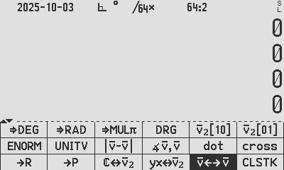   | [→P] conversion from rect to ΁₂ or ΁₃ | No conversion from rectangular to polar with the Angle type
  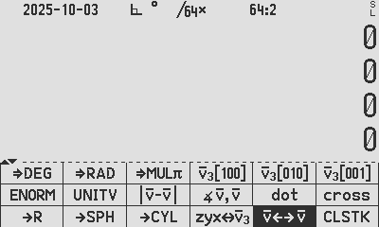 | Change to input polar directly from stack | No implied conversion from rectangular to polar with the polar type selection

Scalar operations from both 2D and 3D pages:
  Copied from MODE/TRG | Scalar numbers entered as angles and converted to other angle modes: | 123 [⇒DEG]  123 [⇒DEG] [⇒RAD] | X: 123.°  X: 2.147^{r}
  Copied from Keyboard/TRG | Angles entered as the current ADM; tagged angles converted to other angle modes: | [DEG]  123 [DRG]  [RAD]  123 [DRG]  [DRG] | X: 123.°  X: 123.^{r}  X: 7830.423^{g}

2D vector operations:
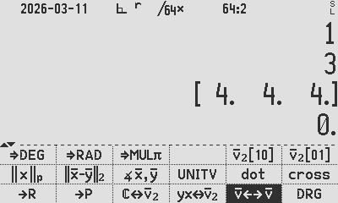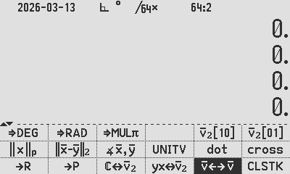
2D: C47 2D: R47

All examples using default 3DXYZ clear:
 | Creating 2D vector; to and from YX on stack: | 4 ENTER 1 [yx⇄΁₂]  4 ENTER 1 [DRG][yx⇄΁₂]  [4. 1.] [yx⇄΁₂]  [4. 1.°]⒑[yx⇄΁₂] | X: [ij] [4. 1.]  X:[rθ_{ij}] [4. 1.°]⒑  X: 4. Y:1.  X: 4. Y:1.°
 | Creating 2D vector;  - to and from stack:  - to and from complex no in x: | 1[i]2 [ℂ⇄΁₂]  [DEG] 1 [i⊚] 2 [ℂ⇄΁₂]  [1 4] [ℂ⇄΁₂] | X:[ij] [1. 2.]  X:[rθ_{ij}] [1. 2.°]⒑  X: 1.+i4.
  Standard g-shifted keys | Rectangular <> Polar commands: | 3 ENTER 4 [yx⇄΁₂] [→P]  2 [i⊚] 60 [ℂ⇄΁₂] [→R] | X:[rθ_{ij}] [5., 53.13°]⒑  X:[ij] [1. 1.732]
   | Change ΁₂ (polar) angle mode, e.g. to Mult𝝅: | 2 [i⊚] 60 [ℂ⇄΁₂] [⇒MUL𝝅] | X: [2. 0.333ⱥ⒓]⒑
 | Create a new unit vector of length 1: | ΁₂[10] 2 * ΁₂[01] 3 * +  ΁₂[10] 3 * ΁₂[01] 2 * + | Y:[ij] [2. 3.]  X:[ij] [3. 2.]
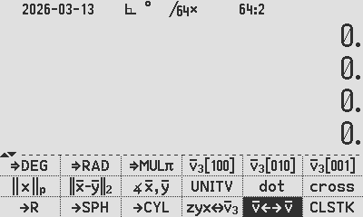 | Euclidean Norm of V in x | [3. 4.] ENORM | X: 5.
 | Create equivalent unit length vector from M or ΁ in x | [3. 2.] UNITV  [0.83295 0.5547] [→P] | Y:[ij] [0.83295 0.5547]  X:[rθ_{ij}] [1. 33.690°]
 | Distance between M or ΁ in x and y | [2. 3.][3. 2.] [͸-ȳ] | X: 1.4142
 | Angle between M or ΁ in x and y | [2. 3.][3. 2.] ∠΁,΁ | X: 22.620°
 | Dot product of M or ΁ in x and y | [2. 3.][3. 2.] dot | X: 12
 | Cross product of ΁ in x and y | [2. 3.][3. 2.] cross | X:[ijk] [0. 0. -5]
  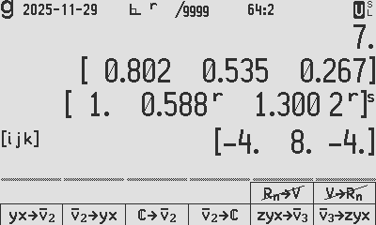 | Single direction vector <> stack conversions: | 1 ENTER 30° [yx→΁₂]  [1., 30°]⒑ [΁₂→yx] | [1., 30°]⒑  Y: 1  X: 30°
   | Single direction vector <> complex conversions: | 1 [i⊚] 30° [ℂ→΁₂]  [1., 30°]⒑ [΁₂→ℂ] | [1., 30°]⒑  1∡30°

3D vector operations:
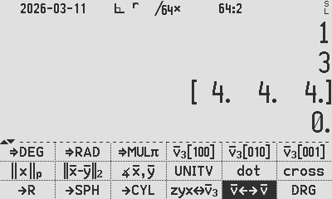
3D: C47 3D: R47
All examples using default 3DXYZ clear, 3DPHYS clear:
 | Creating 3D vector; to and from YX on stack: | 1 EXIT 2 EXIT 3 [zyx⇄΁₃]  1 EXIT 2° EXIT 3° [zyx⇄΁₃]  1 EXIT 2° EXIT 3 [zyx⇄΁₃]  [1. 2.° 3.°]^{S} [zyx⇄΁₃]  [1. 2.° 3.]^{C} [zyx⇄΁₃]  [1. 2. 3.] [zyx⇄΁₃] | X:[ijk] [1. 2. 3.]  X:[ρ θ_{ij} ϕ_{k}] [1. 2.° 3.°]^{S}  X:[rθ_{ij} k] [1. 2.° 3.]^{C}  Z: 1.; Y: 2.°; X: 3.°  Z: 1.; Y: 2.°; X: 3.  Z: 1.; Y: 2.; X: 3.
 | Rectangular <> Spherical <> Cylindrical conversion ( [→P] does [→SPH]) | [1. 2.° 3.°]^{S} [→R]  [1. 30.° 1.]^{C} [→SPH]  [3.×√2 π/6^{r} π/4^{r}]^{S} [→CYL]  [8. 30° 3.] [→R]  [3. 1. 0.]sqrt[→SPH] | X:[ijk][0.052 0.002 .999]  X:[ρθ_{ij} ϕ_{k}][√2 30.° 45.°]^{S}  X: [rθ_{ij} k] [3. π/6^{r} 3.]^{C}  X:[ijk] [4.×√3 4. 3.]  X:[ρθ_{ij} ϕ_{k}] [2. 30° 90°]^{S}
   | Change SPH or CYL vector angle mode, e.g. To Mult𝝅: | [1. -1.57^{r} 3.14^{r}]^{S} [⇒MUL𝝅] | X:[ρθ_{ij} ϕ_{k}][1. -0.5^{πr} 1.^{πr}]^{S}
 | Create a new unit vector of length 1: | ΁₂[100] 2 × ΁₂[010] 3 × +  ΁₂[010] 3 × ΁₂[001] 2 × + | X:[ijk] [2. 3. 0]  X:[ijk] [0. 3. 2]
 | Euclidean Norm of V in x | X:[ijk] [2. 3. 6.] ENORM | X: 7
 | Create equivalent unit length vector from M or ΁ in x | [3. 2. 1.] UNITV | X: [0.802 0.535 0.267]
 | Distance between M or ΁ in x and y | [1. 2. 3.][3. 2. 1.] [͸-ȳ] | 2.×√2
 | Angle between M or ΁ in x and y | [1. 2. 3.][3. 2. 1.] [∠͸,ȳ] | 0.775^{r}
 | Dot product of M or ΁ in x and y | [1. 2. 3.][3. 2. 1.] [dot] | 10
 | Cross product of ΁ in x and y | [1. 2. 3.][3. 2. 1.] [cross] | [-4. 8. -4]
   | Single direction vector conversions | 1 EXIT 2 EXIT 3 [zyx→΁₃]  [1. 2.° 3.°]^{S} [zyx→΁₃] | X:[ijk] [1. 2. 3.]  Z: 1.; Y: 2.°; X: 3.°

2D and 3D Examples with formulas

Cartesian to Cylindrical
Input: r = 3i + 4j + 5k = [3 4 5]
Convert: [x, y, z] → [r, θ, z] where r = √(x² + y²), θ = atan2(y/x), z = z
r = √(3² + 4²) = √25 = 5 θ = arctan(4/3) = 53.130° z = 5
>> Output: [r, θ_{ij}, z_{k}] = [5 53.130° 5]^{C}

Cylindrical to Spherical
Input: [r, θ_{ij}, z_{k}] = [5 53.130° 5]^{C}
Convert: [r, θ_{ij}, z_{k}] → [ρ, θ_{ij}, φ_{k}] where ρ = √(r² + z²), θ = θ, φ = atan2(r/z)
ρ = √(5² + 5²) = √50 = 7.071 θ = 53.130° φ = arctan(5/5) = 45°
>> Output: [ρ, θ_{ij}, φ_{k}] = [7.071, 53.130°, 45°]^{S}

Spherical to Cartesian
Input: [ρ, θᵢⱼ, φₖ] = [7.071, 53.130°, 45°]^{S}
Convert: [ρ, θᵢⱼ, φₖ] → xi + yj + zk where x = ρ·sin(φₖ)·cos(θᵢⱼ), y = ρ·sin(φₖ)·sin(θᵢⱼ), z = ρ·cos(φₖ)
x = 7.071 · sin(45°) · cos(53.130°) = 7.071 · 0.707 · 0.6 = 3 y = 7.071 · sin(45°) · sin(53.130°) = 7.071 · 0.707 · 0.8 = 4 z = 7.071 · cos(45°) = 7.071 · 0.707 = 5
>> Output: [ijk] r = 3i + 4j + 5k = [3 4 5]

Rectangular to Polar
Input: r = 3i + 4j = [3 4]
Convert: [x, y] → [r, θᵢⱼ] where r = √(x² + y²), θᵢⱼ = atan2(y/x)
r = √(3² + 4²) = √25 = 5 θᵢⱼ = arctan(4/3) = 53.130° >> Output: [r, θᵢⱼ] = [5 53.130°]^{P}

Polar to Rectangular
Input: [r, θᵢⱼ] = [5 53.130°]^{P}
Convert: [r, θᵢⱼ] → xi + yj where x = r·cos(θᵢⱼ), y = r·sin(θᵢⱼ)
x = 5 · cos(53.130°) = 5 · 0.6 = 3 y = 5 · sin(53.130°) = 5 · 0.8 = 4 >> Output: r = 3i + 4j = [3 4]

Practical 2D vector problem, from the HP25 Operating Manual, p70
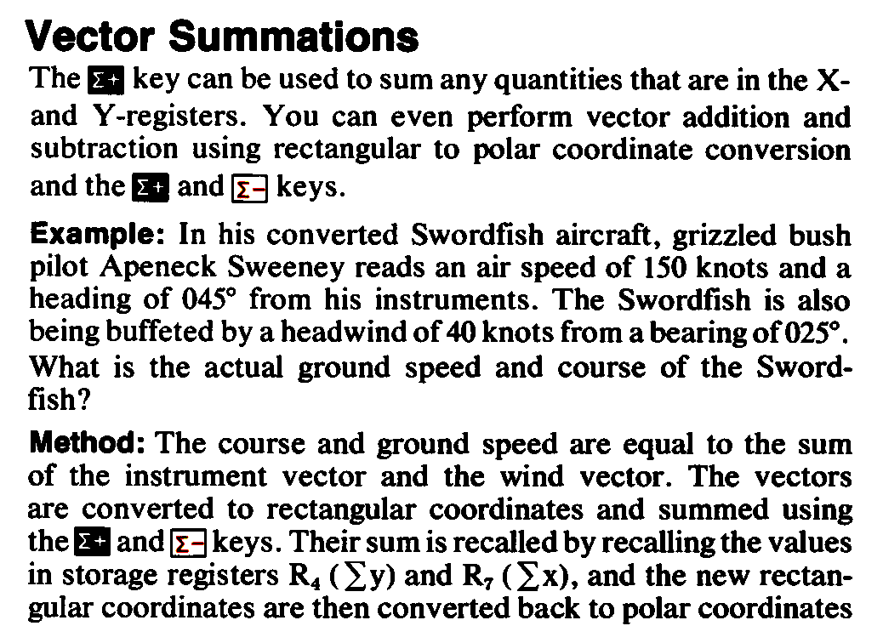
Using R47, assuming default ADM = DEG. The example is displayed in SIG 3. Since we are referencing the same 90° x-axis as reference to all vectors, input, intermediate and output, we do not have to consider the 90° navigation offset from mathematical vector references:
150 ENTER 45 [DRG][yx⇄΁₂] STO ‘AirVel’ 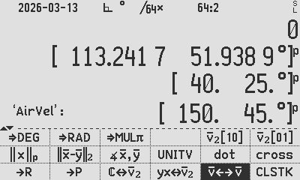
40 ENTER 25 [DRG][yx⇄΁₂] STO ‘Wind’ 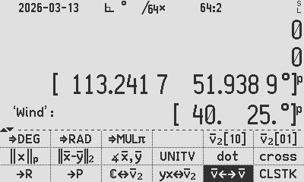
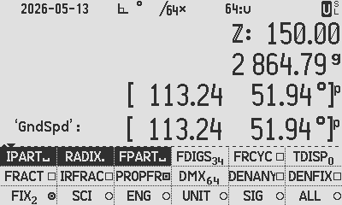
- [→P] STO ‘GndSpd’

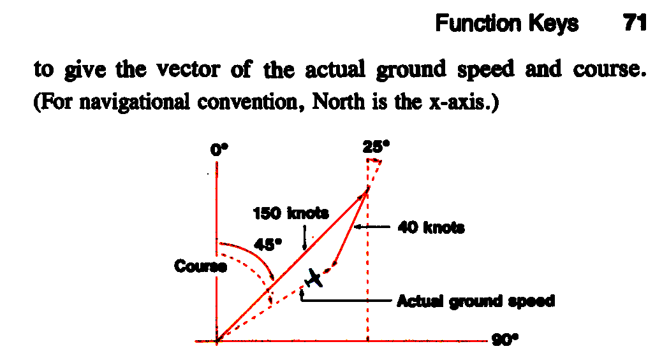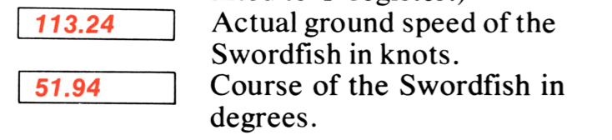

Practical 2D vector problem, from the HP-32E Operating Manual, p28
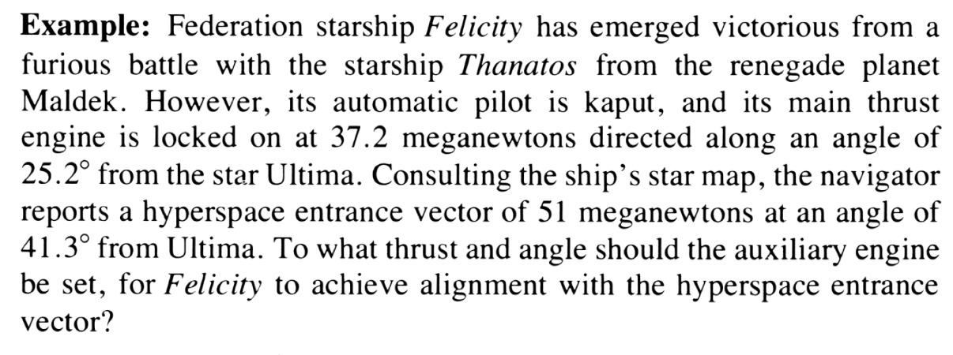

Using R47:
51 ENTER 41.3 [DRG][yx⇄΁₂] STO ‘HypSpc’ 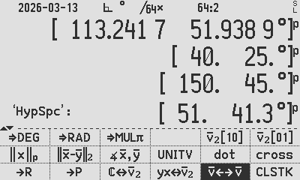
37.2 ENTER 25.2 [DRG][yx⇄΁₂] STO ‘MainEng’ 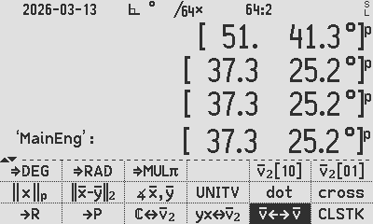
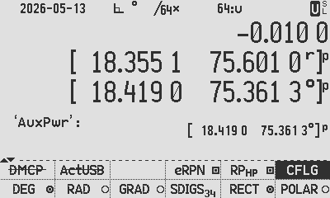
- [→P] STO ‘AuxPwr’ MN from Ultima
??
51 MN 41.3°
37.3 MN 25.2°
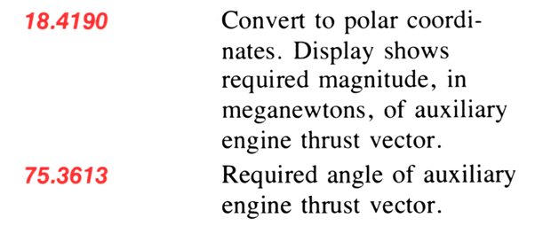

Author Jaco Mostert
Copyright (C) 2026 The R47/C47 Development Team. Permission is granted to copy, distribute and/or modify this document under the terms of the GNU Free Documentation License, Version 1.3 or any later version published by the Free Software Foundation; with no Invariant Sections, no Front-Cover Texts, and no Back-Cover Texts. A copy of the license can be downloaded from gnu.org.

